# **Attendance, Exam, and Assignment Adjustment (AEAA)**

**Please read this document in entirety as there is a specific process for this accommodation and all steps must be followed so that your** **accommodations are managed and used effectively.**

This accommodation will be most effective if you request it at the start of every semester and before something is missed. Your accommodation is not active until you request your accommodation(s) online through the Knights Access portal and either create an AEAA plan with your professor or until your AEAA plan is finalized through SAS, if selecting that option. Below you will find instructions for the two AEAA options you have to complete your plan, Student Initiated AEAA or AEAA coordinated through SAS.

**You must select ONE for each of your courses that you would like to use AEAA for:**

* **AEAA - Student Initiated:** If you want to coordinate the AEAA accommodation on your own with your course professor without SAS involvement.
* **AEAA - Coordinated Through SAS**: If you want SAS to work with your professor to create an AEAA plan for your course.

**There are different instructions for both options. Please follow the instructions below for the option(s) that you choose every semester.**

**AEAA - Student Initiated Accommodation**

1. Log into [Knights Access](https://nam02.safelinks.protection.outlook.com/?url=https%3A%2F%2Fsas.sdes.ucf.edu%2F&data=05%7C02%7CKatherine.Virella%40ucf.edu%7C0a7fd852c1524d150b4508dc5eec4f7b%7Cbb932f15ef3842ba91fcf3c59d5dd1f1%7C0%7C0%7C638489616245217773%7CUnknown%7CTWFpbGZsb3d8eyJWIjoiMC4wLjAwMDAiLCJQIjoiV2luMzIiLCJBTiI6Ik1haWwiLCJXVCI6Mn0%3D%7C0%7C%7C%7C&sdata=gu05p7eYex6cYqSzM9Ik8Ef1VIJZlxSug%2BtIzlN%2BO%2Bk%3D&reserved=0)  and follow the instructions for submitting your accommodation requests.

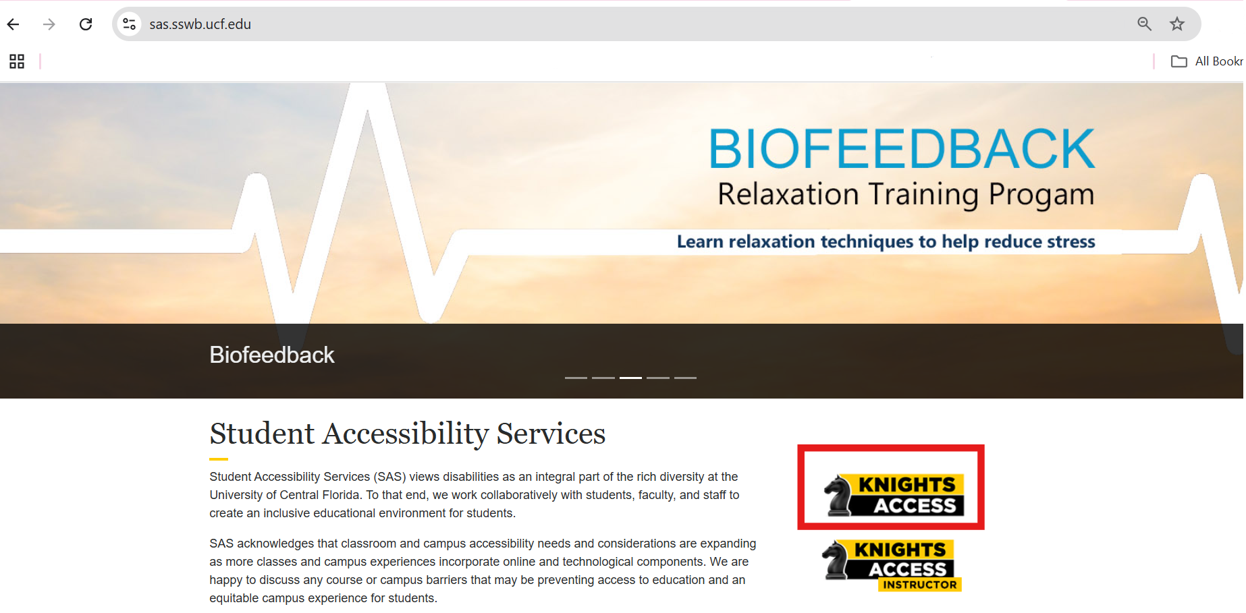

*Figure One: Knights Access Portal button on SAS website outlined with a red rectangle around the log-in button labeled "KNIGHTS ACCESS".*

1. Sign into Knight’s Access using your NID and NID

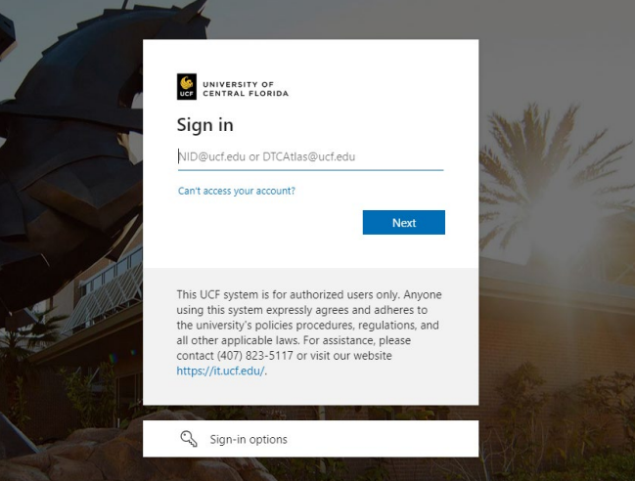

*Figure Two: Knights Access Portal login page screen, with prompt to enter* [*NID@ucf.edu*](mailto:NID@ucf.edu)*.*

1. When you sign into Knights Access, you may see **E-Form agreements** listed on the main page of My Dashboard. Click on each E-Form and review the information as policies and procedures might have changed. You will agree by providing an electronic signature. Select the Submit Form button to agree to the terms and conditions. A copy of this agreement can be found in your mailbox.

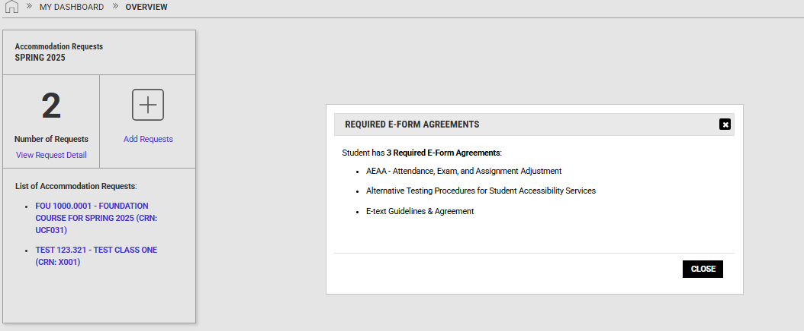

*Figure Three: Screenshot of E-form agreement pop-up on Knight's Access Website.*

1. On the Knight’s Access Portal Dashboard, navigate to and click ‘Add Requests,’ circled in red.

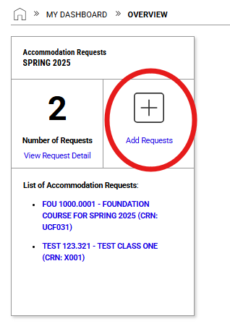

*Figure Four: Knights Access My Dashboard screenshot with red circle around “Add Requests.”*

1. Select all of the courses you wish to request accommodation(s) for and then specify which accommodation(s) you would like to use in each course. Read through the final step and check the box. Scroll down and click “Submit Request.”

* Within your approved accommodation list, select AEAA Student Initiated accommodation to work with your professor directly.
* **If you would like SAS to work with your professor to create an AEAA plan for your course, you will NOT select this accommodation**
* You can select different AEAA options for different courses.
* If you do not want this accommodation, do not select it.

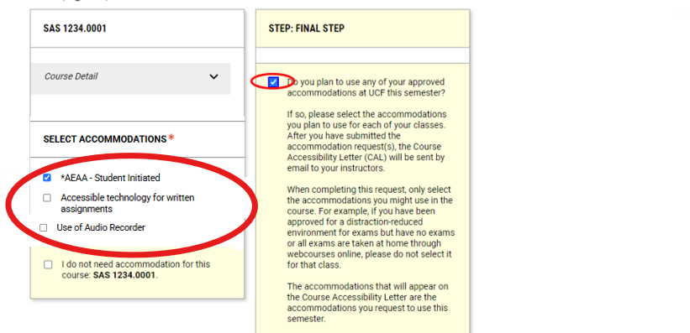

*Figure Five: On the Knight’s Access Portal “Add Request’s Page”, under the “SELECT ACCOMMODATIONS” section on the right side of the screen, “*AEAA-Student Initiated” accommodation is selected and circled in red. On the left side of the screen, on the “FINAL STEP” section, the checkbox is also selected and circled in red.*

1. After submitting your Course Accessibility Letter, you can contact your professor as soon as possible to begin creating an AEAA plan.

* To use AEAA, you must create a plan with your professor BEFORE using the accommodation.
  + To assist with creating the plan on your own, you may want to use the SAS-provided form. A link is provided within the accommodation description in the Course Accessibility Letter and on our [website](https://sas.sswb.ucf.edu/students/accommodations/policy/).
* If you have any issues with creating a plan with your professor, you can email [sas@ucf.edu](mailto:sas@ucf.edu) with any questions or concerns.

**AEAA - Coordinated Through SAS Option**

1. Complete the SAS [Course Request Form](https://ucf.qualtrics.com/jfe/form/SV_2rzFo5o9sSYaKWO) each semester you have classes that you want SAS to work with your professors to create a plan on your behalf. **SAS will not take action until this form is submitted.**

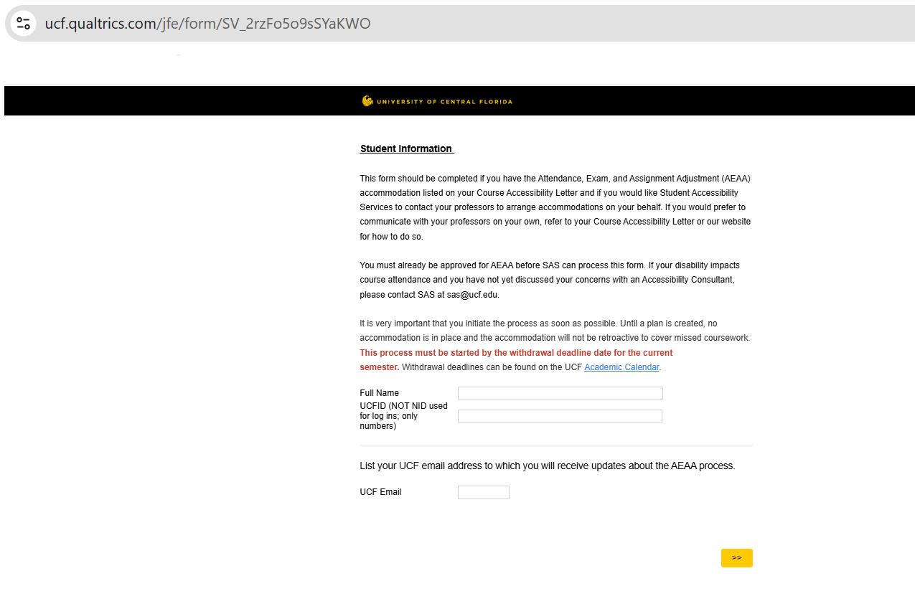

*Figure Six: The AEAA Course Request form link to request the AEAA - Coordinated Through SAS accommodation.*

1. Once the form is received, SAS will update your Course Accessibility Letter to notify your professor(s) that SAS will coordinate your AEAA plan(s).

* Remember that you should not select AEAA - Student Initiated Accommodation if you would like SAS to work with your professors for you.
* **You will need to complete this form every semester**. If you do not complete this form, your professor will not be able to provide you with any assignment, exam, or attendance adjustments.

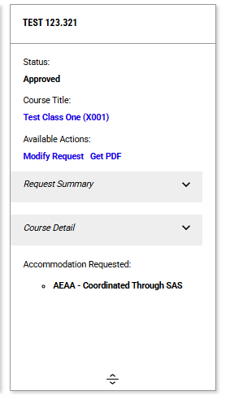

*Figure Seven: Screenshot of AEAA - Coordinated Through SAS on a class accommodation list after SAS staff manually adds this accommodation for the student.*

1. SAS typically begins creating AEAA plans **after** the add/drop period and may take **up to 10 days** to complete.
2. After your professor completes your AEAA plan in their Knight’s Access Instructor Portal, you will receive an email notifying you when a plan has been completed.
3. To review the final plan, you must log in to your [Knight’s Access Portal](https://olympic.accessiblelearning.com/UCF/)

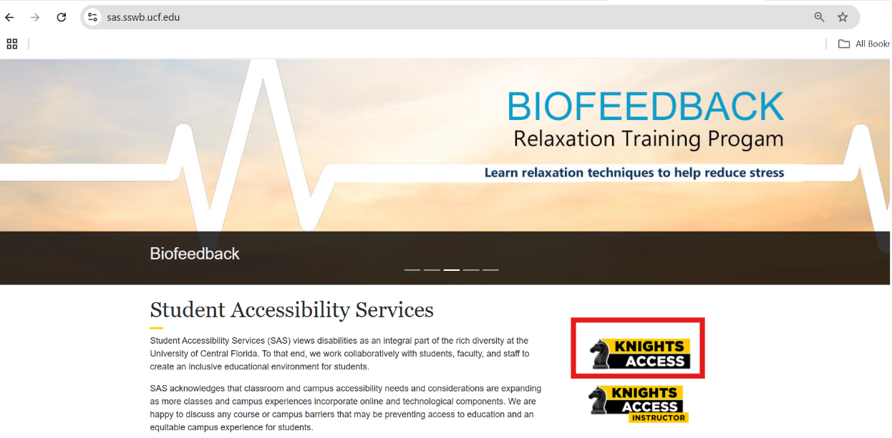

*Figure Eight: Red rectangle surrounding the "KNIGHTS ACCESS INSTRUCTOR" portal button on the SAS website.*

1. Sign into Knight’s Access using your NID and NID



*Figure Two: Knights Access Portal login page screen, with prompt to enter* [*NID@ucf.edu*](mailto:NID@ucf.edu)*.*

1. To review the final plan, click on the Flex Plan module located on the left side of the screen.

* You can refer to your plan(s) within this module as needed throughout the semester.

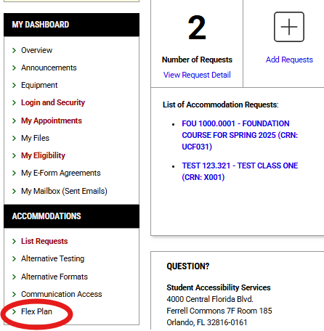

*Figure Ten: Screenshot of Knight's Access Dashboard with red circle around the "Flex Plan" button on the left side of the screen.*

1. If you have any issues with creating a plan with your professor, you can email [sas@ucf.edu](mailto:sas@ucf.edu) or call 407-823-2371 with questions or concerns.

More information regarding AEAA is available on the [SAS website](https://sas.sswb.ucf.edu/students/accommodations/policy/)

For questions, please contact us at [sas@ucf.edu](mailto:sas@ucf.edu) and 407-823-2371.