# **Attendance, Exam, and Assignment Adjustment (AEAA)**

Effective Summer 2025, SAS changed how AEAA is coordinated with faculty. It will be through the Knights Access portal, not through email.

**Please read this document in entirety so that you are aware of the process and all steps that must be followed to ensure that your students' accommodation is managed effectively.**

**Two AEAA Student Options:**

* **AEAA - Student Initiated Accommodation:** If students want to coordinate the AEAA accommodation on their own with course professors without SAS involvement.
* **AEAA - Coordinated Through SAS:** If students want SAS to work with the professor to create an AEAA plan for a course.

The initial Course Accessibility Letter you receive may have **AEAA -- Student Initiated**, which includes details on how students can choose to initiate the AEAA plan directly with their professors.

The accommodation description also includes instructions on how the student can choose to have SAS coordinate the AEAA accommodation on their behalf if they prefer SAS involvement.

If the student requests SAS coordinate the AEAA, they will notify SAS through a form. The professor will then receive an updated Course Accessibility Letter with the accommodation **AEAA Coordinated Through SAS.**

The remainder of this document provides step-by-step instructions regarding the professor’s role for each AEAA option.

**AEAA -- Student Initiated**

1. If the student sends you a Course Accessibility Letter and has selected the **AEAA – Student Initiated** option, it is the responsibility of the student to contact you via email or Webcourses (Canvas) to initiate an AEAA Plan.

* Professors are not required to initiate contact with students about this accommodation but may choose to do so.

2. Create an AEAA Plan with the student that reflects your course policies and provides an appropriate level of flexibility for the student.

* You may want to use our AEAA – Student Initiated Plan document found on our website [here](https://sas.sswb.ucf.edu/faculty/essential-faculty-information/what-is-the-attendance-exam-and-assignment-adjustment-aeaa/) to help guide you through this process.
* SAS recommends that any final plan be confirmed with the student in writing and with specific flexibility details allows, such as how many absences or make-up exams are possible in the event of the medical illness on record with SAS.
* If you have an AEAA plan already created with other students in your course, you can apply the same flexibility with the student requesting the plan now.

3. Because the student selected the option to initiate the plan, the plan should be shared with the student via email.

* The professor and student will not see the AEAA – Student Initiated plans in their Flex Plan Module.
* It is not required that you send the AEAA – Student Initiated plan to SAS for approval.

4. If you have any issues or questions during this process, contact SAS at [sas@ucf.edu](mailto:sas@ucf.edu) or call 407-823-2371.

**AEAA - Coordinated Through SAS**

With the **AEAA - Coordinated Through SAS** accommodation, professors **must** take the following actions after they receive the Course Accessibility Letter with the **AEAA – Coordinated Through SAS** accommodation listed on the letter:

1. Log into the [Knights Access Instructor Portal](https://nam02.safelinks.protection.outlook.com/?url=https%3A%2F%2Folympic.accessiblelearning.com%2FUCF%2Finstructor%2F&data=05%7C02%7CAdam.Meyer%40ucf.edu%7C4cf46a0268a54409b9b908dc53dc3450%7Cbb932f15ef3842ba91fcf3c59d5dd1f1%7C0%7C0%7C638477452436527599%7CUnknown%7CTWFpbGZsb3d8eyJWIjoiMC4wLjAwMDAiLCJQIjoiV2luMzIiLCJBTiI6Ik1haWwiLCJXVCI6Mn0%3D%7C0%7C%7C%7C&sdata=D82BwhTfL59celIZS8RjTVHniomxe0SK8H0UgxUVS48%3D&reserved=0)

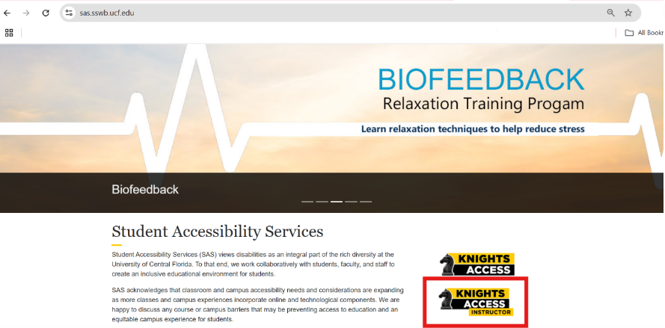

*Figure One: Red rectangle surrounding the "KNIGHTS ACCESS INSTRUCTOR" portal button on the SAS website.*

2. Click on “Flex Plan” option located on the left-hand menu

*Figure Two: Red circle surrounding the "FLEX PLAN" portal button on the left side of the screen.*

3. Select the course that you have received notification to create a plan for in the Flex Plan Module and click “View”.

* Please note that you will **NOT** see the student’s name who requested the AEAA – Coordinated Through SAS option on this screen. You can identify students that have requested AEAA through the Course Accessibility Letter sent to your UCF email.

*Figure Three: Red circle surrounding the "View" button on the left side of the Flex Plan Module.*

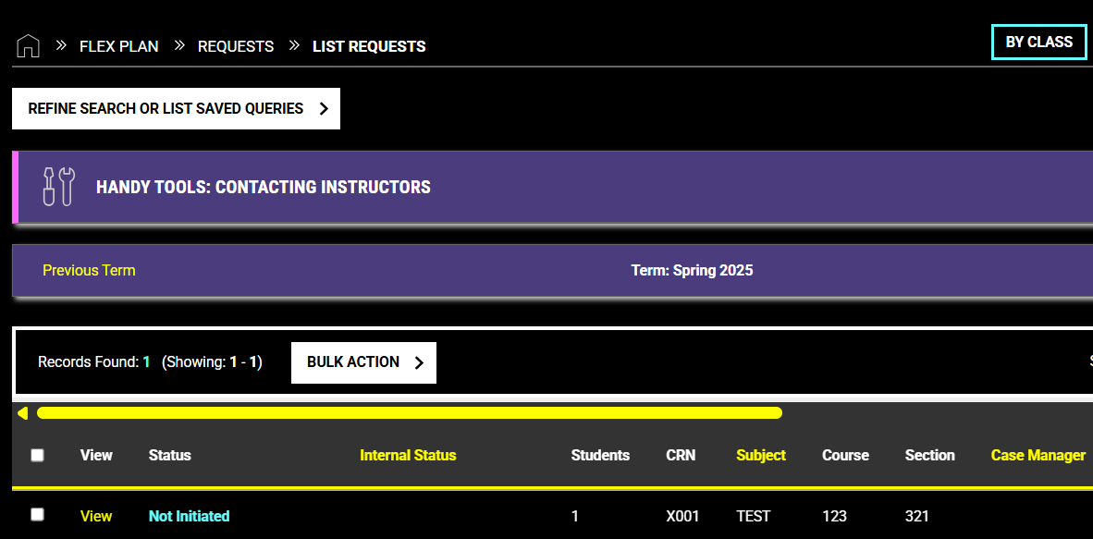

4. **Complete the AEAA Questionnaire within 7 days.**

* You will need to answer the questions in the survey outlining what flexibility is already available in your course for all students and what additional flexibility can be offered for the student with the AEAA accommodation.
* When completing the survey, you may see boxes already checked on the form. This is SAS’s Default AEAA Plan. You can change the options to fit your course.
* Please note that the student will see any comments you include in the questionnaire once SAS approves the plan.
* **If you do not complete the plan within 7 days**, SAS will automatically apply their default plan to your course with the most generous amount of flexibility.

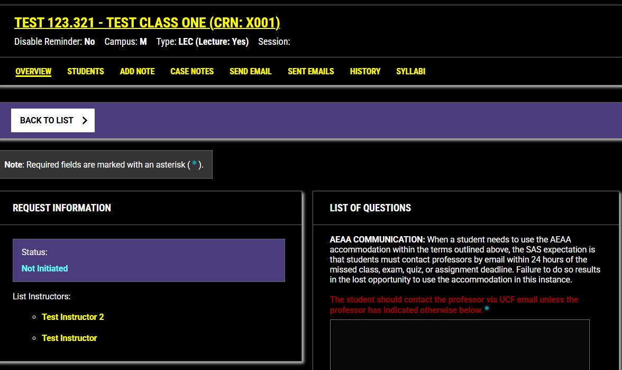

*Figure Four: The AEAA survey page list of questions in the Knight's Access Instructor Portal Flex Plan Module*

4. Once you complete the survey, an SAS staff member will review it. If SAS has any questions, we will contact you via email.

5. The professor and student will be notified by email once the plan has been finalized.

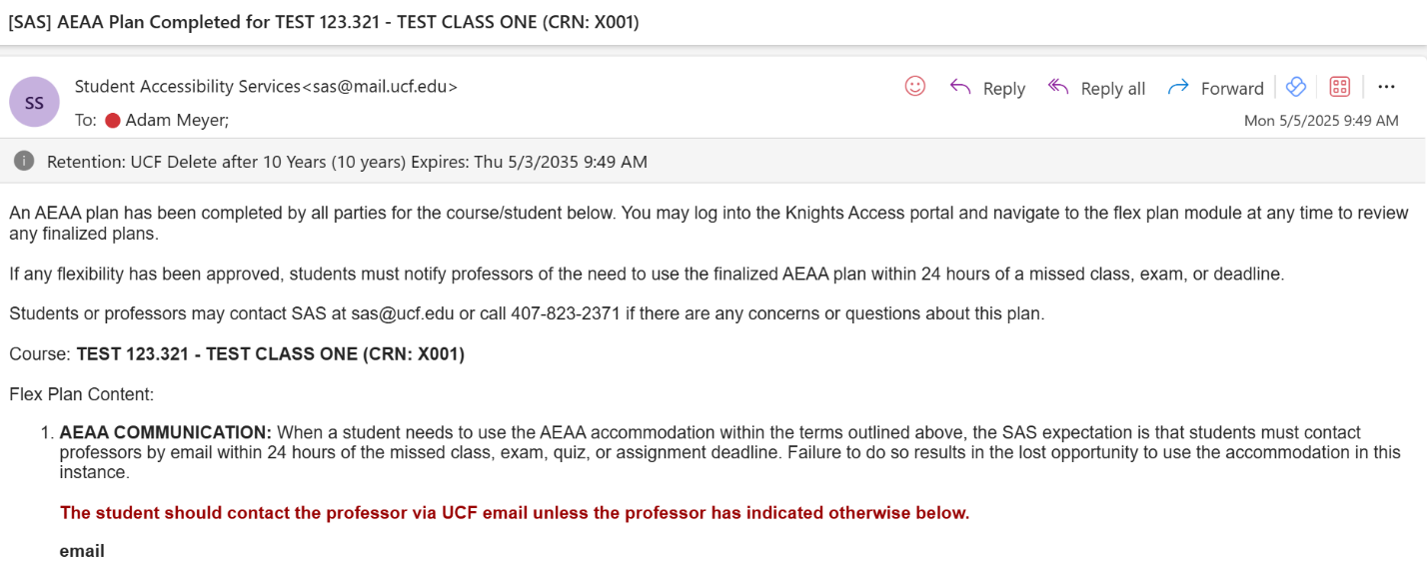*Figure Five: Screenshot of the [SAS] AEAA Plan Completed for Course confirmation email.*

6. The plan will be stored in the Knights Access Flex Plan Module for reference.

* The student must contact the professor within 24 hours of needing to use the terms of the plan should a medical need arise.

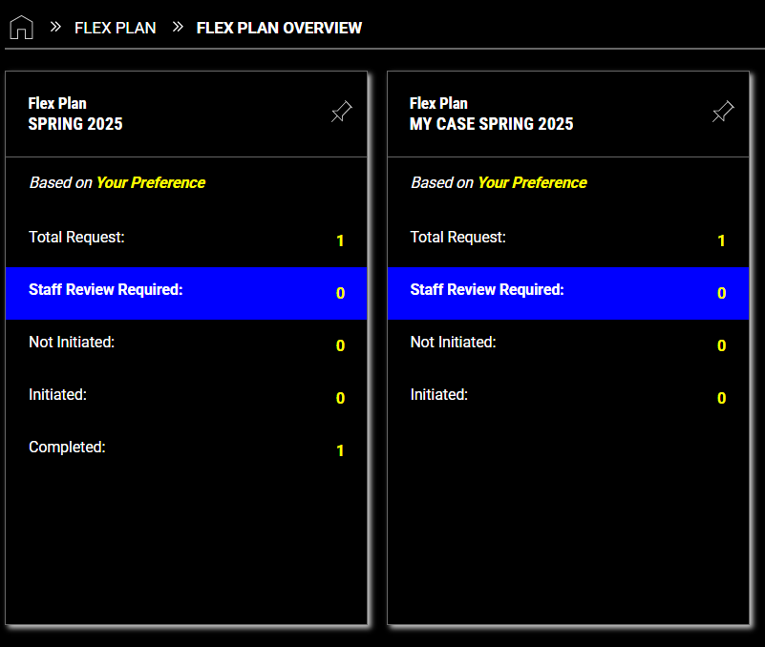

*Figure Six: Screenshot of the "Flex Plan Overview" screen in the Knight's Access Instructor Portal*

**Duplicating Plans**

**The completed plan will be used for all students in this specific course (same prefix, section, and CRN)**

* After the first student plan is created for a specific course and section number (CRN), then that AEAA plan will automatically be applied to any other student with the **AEAA – Coordinated by SAS** accommodation in that course. No further action is needed to transfer the plan for student requests taking **the exact same course.**

**If you would like to use this plan for another course, follow these steps:**

1. If you would like to apply the same AEAA plan to a different section of the same course or an entirely different course, you will be able to copy the plan over to the desired section or course**.**

* Plans made in past semesters can also be copied over to current courses.
* All information for students, professors, and SAS will be stored within the Flex Plan module without having to manage multiple emails.

2. Select the “View” on the plan that you would like to Copy.

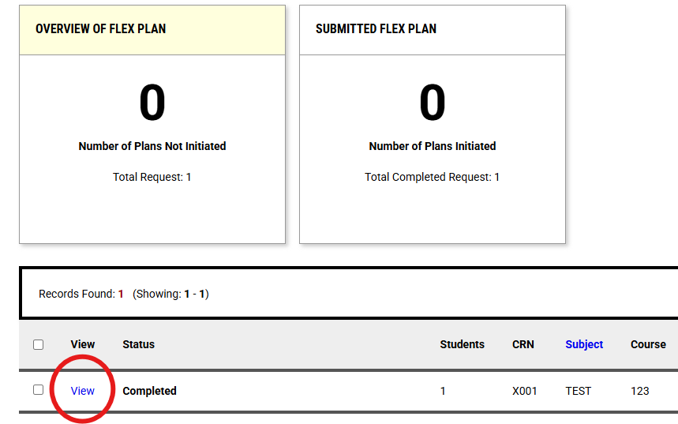

*Figure Seven: Red circle around the "View" button on the left side of the Flex Plan Module Dashboard.*

3. Click “Copy Flex Plan”, then indicate the new CRN that you would like to copy the plan to.

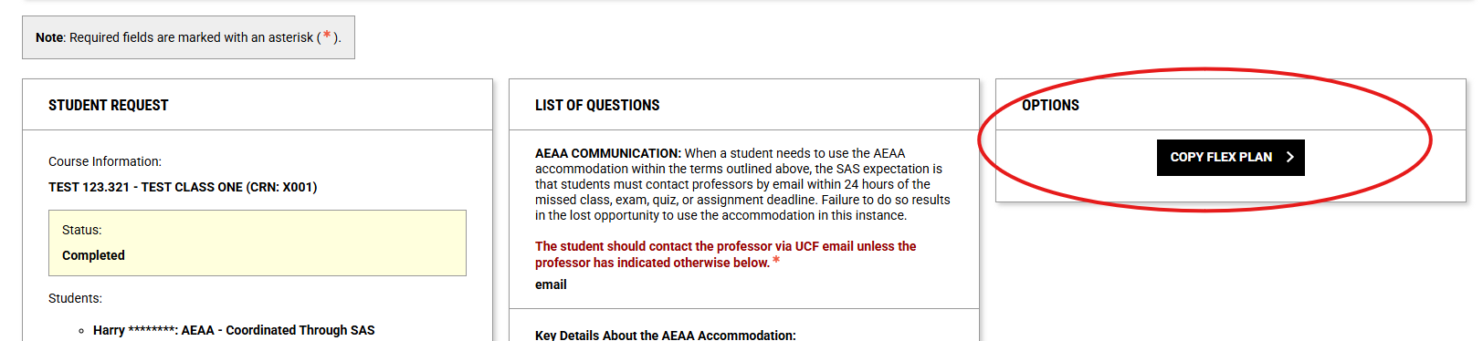

*Figure Eight: Red circle around the "OPTIONS" section and "COPY FLEX PLAN" button of a previously completed Flex Plan.*

**As a reminder:**

* The Attendance, Exam, and Assignment Adjustment (AEAA) accommodation is for students with chronic conditions that may impact attendance or coursework.
* Missed course events (attendance, exams/quizzes, or assignments) that occur before AEAA plans are finalized will be addressed through the course policies and not the AEAA accommodation.
* Students must notify professors of the need to use the finalized AEAA plan within 24 hours of a missed class, exam, or deadline.
* For students who use this accommodation, a doctor’s note should NOT be requested.
* AEAA offers reasonable flexibility that varies by course and does not necessarily cover frequent or extended absences, guarantee deadline extensions for all assignments, or apply to all coursework by default.
* AEAA is not for everyday illnesses or absences unrelated to the documented chronic condition on file with SAS.
* Remote attendance, course recordings, and course notes are not provided/included as part of the AEAA accommodation.
* Extended absences (e.g., a week or more) require **direct coordination with the professor**. In these cases, SAS can be involved (optional). Additional planning may be necessary.

More information regarding AEAA is available on the [SAS website](https://sas.sswb.ucf.edu/faculty/essential-faculty-information/what-is-the-attendance-exam-and-assignment-adjustment-aeaa/).

For questions, please contact us at [sas@ucf.edu](mailto:sas@ucf.edu) and 407-823-2371.